Ex 15: Sorting Techniques

Name: Rowin.U

RegNo.:231801141

QUICK SORT:

PROGRAM:

#include <stdio.h>

void swap(int* a, int* b)

{

int temp = *a;

*a = *b;

*b = temp;

}

int partition(int arr[], int low, int high)

{

int pivot = arr[low];

int i = low;

int j = high;

while (i < j) {

while (arr[i] <= pivot && i <= high - 1) {

i++;

}

while (arr[j] > pivot && j >= low + 1) {

j--;

}

if (i < j) {

swap(&arr[i], &arr[j]);

}

}

swap(&arr[low], &arr[j]);

return j;

}

void quickSort(int arr[], int low, int high)

{

if (low < high) {

int partitionIndex = partition(arr, low, high);

quickSort(arr, low, partitionIndex - 1);

quickSort(arr, partitionIndex + 1, high);

}

}

int main()

{

int arr[] = { 19, 17, 15, 12, 16, 18, 4, 11, 13 };

int n = sizeof(arr) / sizeof(arr[0]);

printf("Original array: ");

for (int i = 0; i < n; i++) {

printf("%d ", arr[i]);

}

quickSort(arr, 0, n - 1);

printf("\nSorted array: ");

for (int i = 0; i < n; i++) {

printf("%d ", arr[i]);

}

return 0;

}

OUTPUT:

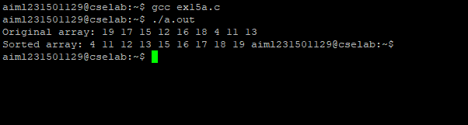

MERGE SORT:

PROGRAM:

#include <stdio.h>

#include <stdlib.h>

void merge(int arr[], int l, int m, int r)

{

int i, j, k;

int n1 = m - l + 1;

int n2 = r - m;

int L[n1], R[n2];

for (i = 0; i < n1; i++)

L[i] = arr[l + i];

for (j = 0; j < n2; j++)

R[j] = arr[m + 1 + j];

i = 0;

j = 0;

k = l;

while (i < n1 && j < n2) {

if (L[i] <= R[j]) {

arr[k] = L[i];

i++;

}

else {

arr[k] = R[j];

j++;

}

k++;

}

while (i < n1) {

arr[k] = L[i];

i++;

k++;

}

while (j < n2) {

arr[k] = R[j];

j++;

k++;

}

}

void mergeSort(int arr[], int l, int r)

{

if (l < r) {

int m = l + (r - l) / 2;

mergeSort(arr, l, m);

mergeSort(arr, m + 1, r);

merge(arr, l, m, r);

}

}

void printArray(int A[], int size)

{

int i;

for (i = 0; i < size; i++)

printf("%d ", A[i]);

printf("\n");

}

int main()

{

int arr[] = { 12, 11, 13, 5, 6, 7 };

int arr_size = sizeof(arr) / sizeof(arr[0]);

printf("Given array is \n");

printArray(arr, arr_size);

mergeSort(arr, 0, arr_size - 1);

printf("\nSorted array is \n");

printArray(arr, arr_size);

return 0;

}

OUTPUT:

